Hanmi to Unveil Second Muscle-Building Obesity Candidate at ADA 2026
<World’s First Peptide-Based Long-Acting Myostatin Inhibitor (LA-MSTN), HM500197, to Debut>

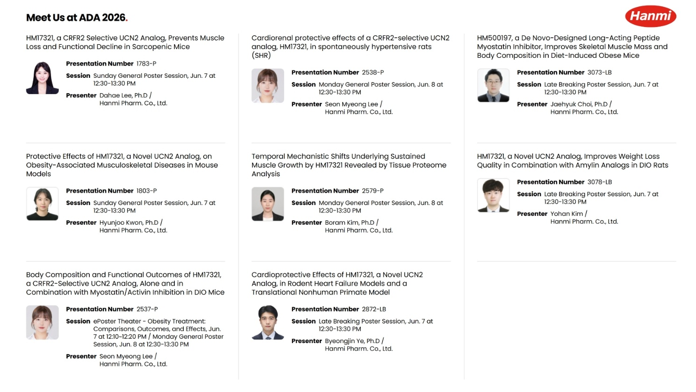
Hanmi to Present Eight Studies on Two Muscle-Building Obesity Candidates at ADA 2026 in June
Around 20 Researchers, Including Dr. Choi, to Share Key Findings with the Global Scientific Community
Overview of key poster abstracts to be presented by Hanmi at ADA 2026 (Source: Hanmi Pharmaceutical website).
(May 27, 2026) Hanmi is unveiling for the first time an “innovative obesity drug candidate” featuring the world’s first peptide-based myostatin (myostatin) inhibitory mechanism that simultaneously achieves a quantitative increase in muscle mass and improvements in muscle function.

Hanmi Pharmaceutical, the core operating company of Hanmi Science, announced on May 27, that it will participate in ADA 2026 (American Diabetes Association), to be held in New Orleans, U.S., from June 5 to 8, and present eight research results on two obesity drug candidates: “a novel obesity therapy (LA-UCN2, HM17321)” and “a next-generation, muscle-enhancing therapy (LA-MSTN, HM500197).”

The next-generation muscle-enhancing therapy “LA-MSTN (HM500197),” being disclosed for the first time, is a new pipeline distinct from the existing innovative obesity drug candidate “LA-UCN2 (HM17321).” This development is viewed as securing two major next-generation pipelines in the muscle-strengthening-based obesity treatment space. In particular, strong expectations are building as HM500197’s development strategy, differentiation points, and preclinical study findings are set to be presented for the first time.

While GLP-1–based obesity therapies have demonstrated strong weight-loss efficacy, it has been consistently reported that approximately 20–40% of weight lost is associated with reductions in lean mass. Excessive loss of skeletal muscle, in particular, can lead to decreases in basal metabolic rate and weakening of strength and physical function, factors considered critical for long-term weight maintenance and the health of older patients.

To address these limitations of GLP-1–based therapies, the global biopharma industry has been focusing on combination-treatment research that modulates myostatin (myostatin) and activin (activin) pathways, which are involved in muscle growth.

However, all candidates currently under development in the industry are concentrated on antibody and Fc fusion protein (Fc fusion)–based approaches. Due to their relatively large molecular size, these approaches have clear limitations in developing combination formulations with incretin-based agents. In addition, because their mechanisms often inhibit multiple ligands simultaneously, concerns have been raised about potential effects on off-target physiological pathways, leading to safety considerations as well.

Designed as a “peptide-based” molecule, HM500197 is the fourth core pipeline of the H.O.P project created to overcome the limitations of antibody-based approaches. It is an innovative candidate derived using Hanmi’s proprietary AI-driven Research Platform, HARP, developed in-house based on Hanmi’s proprietary drug-design capabilities.

Through its obesity drug project H.O.P (Hanmi Obesity Pipeline), Hanmi is building a full-cycle obesity portfolio capable of delivering “patient-tailored treatment solutions,” based on a stratified strategy reflecting body-weight levels and metabolic characteristics.

Hanmi is systematically preparing all necessary steps for the successful commercialization of efpeglenatide, the leading program within the H.O.P project, within this year, and has launched a companywide consultative body to further strengthen execution.

Following the innovation of efpeglenatide, the “next-generation triple-agonist obesity therapy (LA-GLP/GIP/GCG, HM15275)” and the “world’s first muscle-gaining obesity therapy (LA-UCN2, HM17321)” have entered Phase 2 and Phase 1 clinical trials in the United States, respectively, and have been progressing smoothly through clinical development.

Dr. In Young Choi, Head of Hanmi Pharmaceutical’s Future Growth Division, said, “Among domestic biopharma companies, Hanmi not only has the earliest timeline for commercializing an independently developed obesity drug candidate, but is also creating the ‘obesity medicines of the future’ based on our unparalleled R&D capabilities built over many years in the metabolic disease field.” He added, “We will successfully complete the development of globally innovative new drugs so that obesity patients worldwide can achieve ‘healthy weight loss’—effectively reducing body fat while actually strengthening muscle.”
<end>

■ Contact info:
Hanmi Pharmaceutical (www.hanmipharm.com)
innovation@hanmi.co.kr, +82-02-410-0467

