Hanmi Begins Dosing in Phase 2 Trial of Belvarafenib, a Novel Melanoma Therapy
<Oral Targeted Anticancer Agent>

First patient enrolled and dosed in Phase 2 trial at a domestic university hospital on February 23
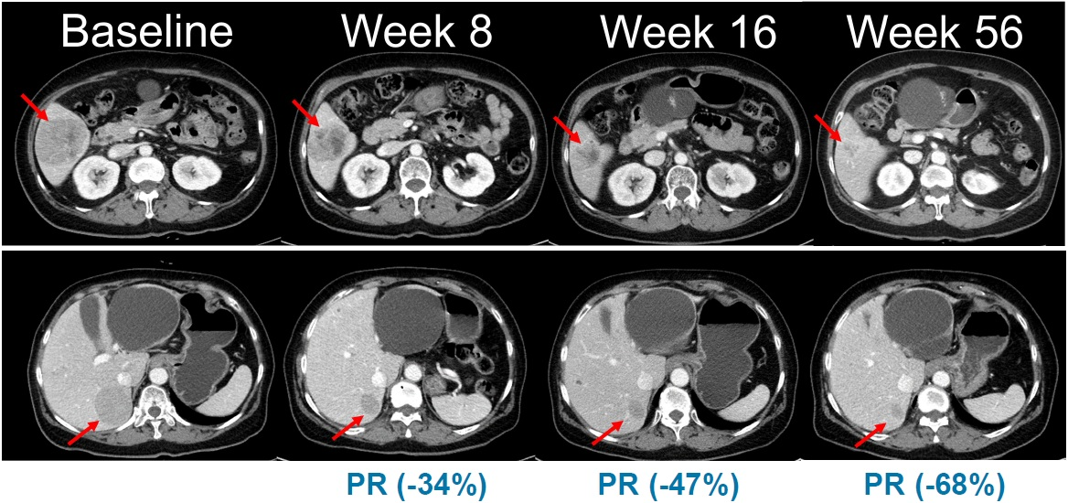
Meaningful antitumor efficacy in NRAS-mutant melanoma patients with no available therapies in Korea or globally
Abdominal CT images showing changes in tumor lesions over time in a clinical trial of combination therapy with belvarafenib and cobimetinib in patients with NRAS-mutant melanoma. (Source: Oral presentation at the American Society of Clinical Oncology [ASCO] Annual Meeting, 2021)

(February 0, 2026) For the first time in Korea, Hanmi has begun patient dosing in a domestic Phase 2 clinical trial of Belvarafenib, a novel oral targeted anticancer therapy for the treatment of melanoma, a malignant skin cancer.

Hanmi Pharmaceutical, a core operating company of Hanmi Science, announced on OO that it enrolled the first patient and completed the first administration in a Phase 2 clinical trial evaluating Belvarafenib in patients with locally advanced or metastatic melanoma harboring NRAS mutations at a domestic university hospital on OO.

Notably, the first patient was dosed in just about one month after the Ministry of Food and Drug Safety (MFDS) approved the Phase 2 investigational new drug (IND) application for Belvarafenib in January, underscoring the rapid progress of the clinical program.

This Phase 2 trial is being conducted as a multicenter, single-arm study in a total of 45 patients to evaluate the efficacy and safety of a combination therapy of Belvarafenib and cobimetinib, a MEK inhibitor.

Melanoma is a difficult-to-treat cancer with limited treatment options and a high risk of recurrence, and most currently available therapies are supplied by foreign pharmaceutical companies.

In particular, NRAS-mutant melanoma represents an area of high unmet medical need, with poor prognosis and no approved standard-of-care therapies in Korea or globally. In current clinical practice, Belvarafenib is being administered on a limited basis to certain patients under treatment-purpose use approval (compassionate use).

Dr. Young Su Noh, Head of Hanmi’s ONCO Clinical Research and Development Team, stated, “Through this Phase 2 trial, we will closely examine therapeutic efficacy in the NRAS-mutant melanoma patient population and do our utmost to execute clinical development in a more systematic and accelerated manner to deliver encouraging results.”

Belvarafenib, originally developed by Hanmi Pharmaceutical, is an oral targeted anticancer agent designed to inhibit RAF and RAS gene mutations within the mitogen-activated protein kinase (MAPK) pathway, which is involved in tumor cell growth and proliferation.

Based on its differentiated mechanism as a selective RAF dimer inhibitor, Belvarafenib targets tumors harboring BRAF Class II/III alterations and RAS mutations. Unlike conventional BRAF inhibitors that primarily suppress RAF monomers, Belvarafenib is designed to inhibit both BRAF and CRAF dimers, enabling it to overcome resistance issues associated with RAF dimer formation.

Accordingly, the combination therapy of Belvarafenib and cobimetinib is regarded as a treatment strategy capable of overcoming the mechanistic limitations of existing BRAF monomer–MEK inhibitor combination therapies while offering potential clinical benefits across a broader range of genetically defined patient populations.

Jae Hyun Park, CEO of Hanmi Pharmaceutical, said, “We remain fully committed to developing innovative new medicines that can offer new hope to cancer patients suffering without adequate treatment options,” adding, “We will dedicate every effort to ensuring that Belvarafenib can become a key treatment option that meaningfully closes the long-standing treatment gap in melanoma and other rare and intractable cancers.”

<The End>

■ Contact info:
〮Official Websites: www.hanmipharm.com
innovation@hanmi.co.kr, +08-2-410-0467

