Hanmi to Advance Next-Generation Immuno-Oncology Candidate Across Monotherapy and Combination Trials
< ^{LAPS}IL-2 analog, Code Name: HM16390>

Hanmi Presents Four Research Studies on HM16390 at SITC
Dose-Escalation Part Ongoing in Global Phase 1 Trial Monotherapy Arm
Combination Study with MSD’s (Merck & Co., Inc., Rahway, NJ, USA) anti-PD-1 therapy, KEYTRUDA® (pembrolizumab) is anticipated to progress in the first half of next year
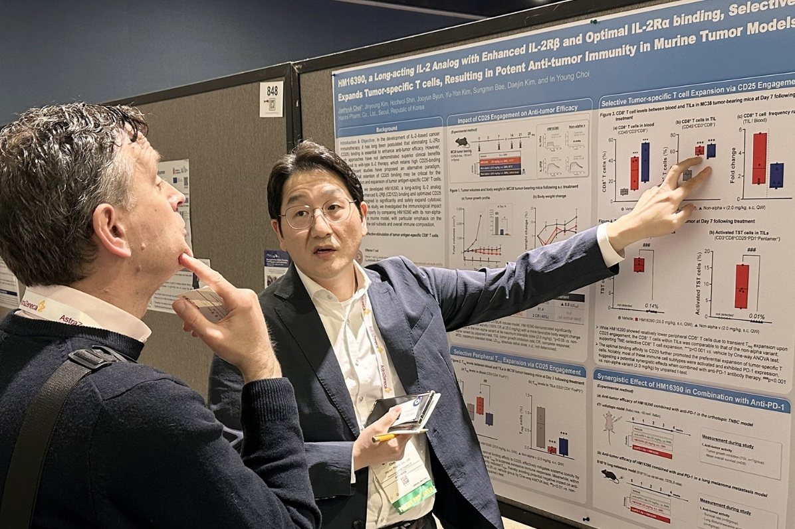
Jaehyuk Choi, Group Leader of Hanmi R&D Center, presented a poster detailing the differentiated development strategy and excellent efficacy data of the next-generation immuno-oncology therapy candidate HM16390 at the SITC 2025 conference.

(November 00, 2025) — Hanmi Pharmaceutical, the core operating company of Hanmi Science, is steadily advancing the clinical development of its next-generation immuno-oncology therapy – an agent that previously demonstrated complete remission of malignant tumors in preclinical studies - building on further progress shown in recent research.

Hanmi announced on [DATE] that it presented four posters covering research outcomes and clinical progress of its ‘^{LAPS}IL-2 analog (HM16390)’ at the Society for Immunotherapy of Cancer (SITC), held from November 5 to 9 (local time) in National Harbor, Maryland, USA.

HM16390 is a next-generation IL-2 (Interleukin-2) analog engineered variant with a differentiated strategy to modulate the differentiation and proliferation of immune cells. By applying its proprietary ‘LAPSCOVERY’ platform to HM16390, Hanmi is developing HM16390 as a long-acting agent optimized to maximize both efficacy and safety, enabling once-per-treatment-cycle subcutaneous (SC) administration in cancer therapy.

Currently, the approved recombinant IL-2 therapy, aldesleukin is recommended only for limited clinical use due to severe adverse events such as vascular leak syndrome and cytokine release syndrome. Conventional IL-2 candidates focused mainly on minimizing systemic toxicity, but they ultimately failed to demonstrate sufficient efficacy, revealing clear limitations in their development.
In contrast, Hanmi’s HM16390 is being developed with a novel strategy that aims to ‘capture both efficacy and safety,’ by enhancing IL-2 beta-receptorbinding to improve antitumor efficacy while optimizing IL-2 alpha-receptorbinding to enhance safety.

At SITC, Hanmi demonstrated that HM16390 – through its optimized IL-2 alpha-receptor affinity – induces a transient and selective increase of regulatory T cells (Treg) only in the bloodstream, not within tumors, thereby attenuating excessive systemic immune activation and reducing systemic toxicity, as directly shown in a Treg-depleted mouse model.

Another poster highlighted that, when compared with a non-alpha variant, only HM16390 induced a significant increase in tumor-specific CD8⁺ T cells (TST), most of which exhibited activated phenotypes characterized by PD-1 expression on the T-cell surface. These results further reinforce the mechanistic differentiation of HM16390, demonstrating that the IL-2 alpha-receptorbinding contributes not only to safety but also to efficacy.

◆ Combination Potential with PD-1 and Other Immune Checkpoint Inhibitors Expected

At the conference, Hanmi also presented new study results, in collaboration with Professor Jung Kyoon Choi’s lab at KAIST’s Department of Bio and Brain Engineering, aimed at identifying transcriptomic biomarkers that may predict immunotherapeutic response to HM16390 prior to initiating combination clinical trials with MSD’s (Merck & Co., Inc., Rahway, NJ, USA) anti-PD-1 therapy, KEYTRUDA® (pembrolizumab).

The research employed multivariate analyses integrating bulk transcriptomic data from approximately 5,000 patients across nine tumor types, along with single-cell transcriptomic data from approximately 600 patients across five tumor types. The analysis revealed that IL-2-related immune signaling pathway and T-cell characteristics are associated with responsiveness to immune checkpoint inhibitors (ICIs).

By leveraging bulk patient transcriptomic datasets and statistical multivariate predictive modeling, the study provides a framework to predict immunotherapy responses and guide appropriate patient stratification. These results support the application of a biomarker-driven, personalized treatment strategy in HM16390’s ongoing global Phase 1 clinical trials.
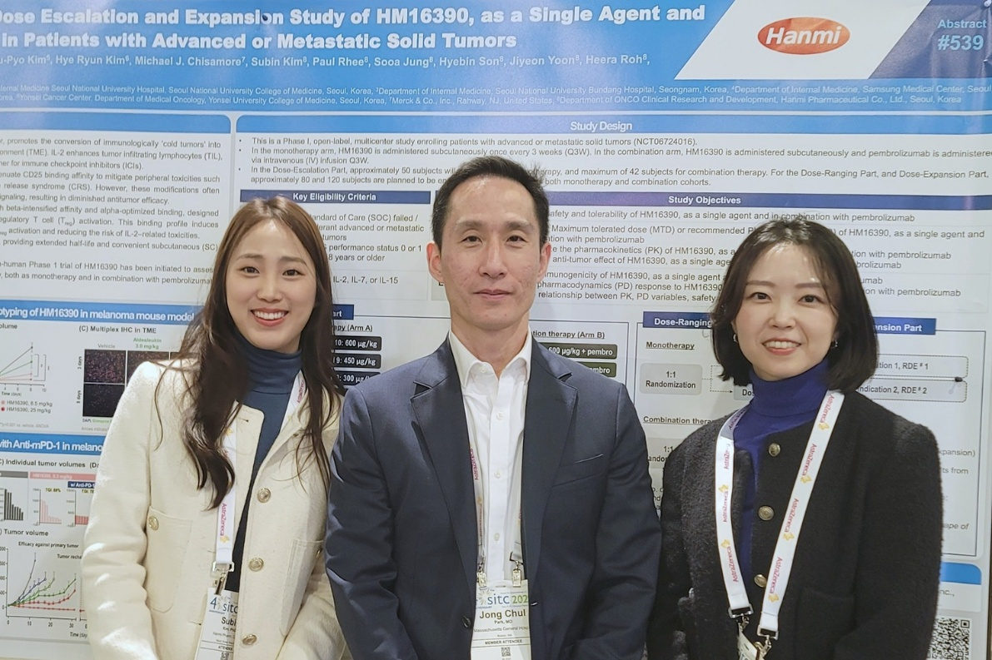

Dr. Jongchul Park (center), professor at the Head and Neck Cancer Center at Harvard Medical School, Massachusetts General Hospital (MGH), and principal investigator for the Phase 1 clinical trial of HM16390, posed with members of Hanmi’s ONCO Clinical Team, Sooa Jung (right) and Subin Kim (left), at SITC 2025.

Hanmi is developing its next-generation immuno-oncology drug candidate HM16390 not only as a monotherapy for various solid tumors, but also as a combination therapy with immune checkpoint inhibitors, based on strong preclinical results.

A global Phase 1 clinical trial is currently underway in South Korea and the United States to evaluate the safety, tolerability, pharmacokinetics, and pharmacodynamics of HM16390 as a monotherapy and in combination with KEYTRUDA in patients with advanced or metastatic solid tumors.

At SITC, Hanmi also introduced the clinical research background, trial design, and current status of HM16390. The dose-escalation part of the monotherapy arm in the global Phase 1 trial is progressing smoothly, and Hanmi expects to advance into the combination arm with KEYTRUDA in the first half of next year.

Youngsu Noh, Director and Head of ONCO Clinical Research and Development at Hanmi, stated, “HM16390, which achieves potent antitumor efficacy while maintaining an excellent safety profile, is expected to enhance treatment responses by modulating the tumor microenvironment both as a monotherapy and in combination with ICIs. We will continue to advance the global clinical program and aim to successfully develop this next-generation immuno-oncology therapy.”
Dr. In Young Choi, Executive Vice President and Head of the R&D Center, stated, “Unlike previous IL-2 analog development strategies, HM16390 was specifically designed to secure both antitumor efficacy and safety. We expect it to establish itself as a promising immuno-oncology therapy by offering broad therapeutic potential across multiple tumor types, while inducing robust antitumor immune responses with minimal adverse effects.”

KEYTRUDA® is a registered trademark of Merck Sharp & Dohme Corp., a subsidiary of Merck & Co., Inc., Rahway, NJ, USA.

<The End>
■ Contact info:
Official Websites: www.hanmipharm.com
innovation@hanmi.co.kr, +08-2-410-0467

