Hanmi Highlights Next-Generation Obesity Pipelines at ObesityWeek 2025
Presentations Feature First-in-Class CRFR2-Selective HM17321 and Best-in-Class Triple Agonist HM15275
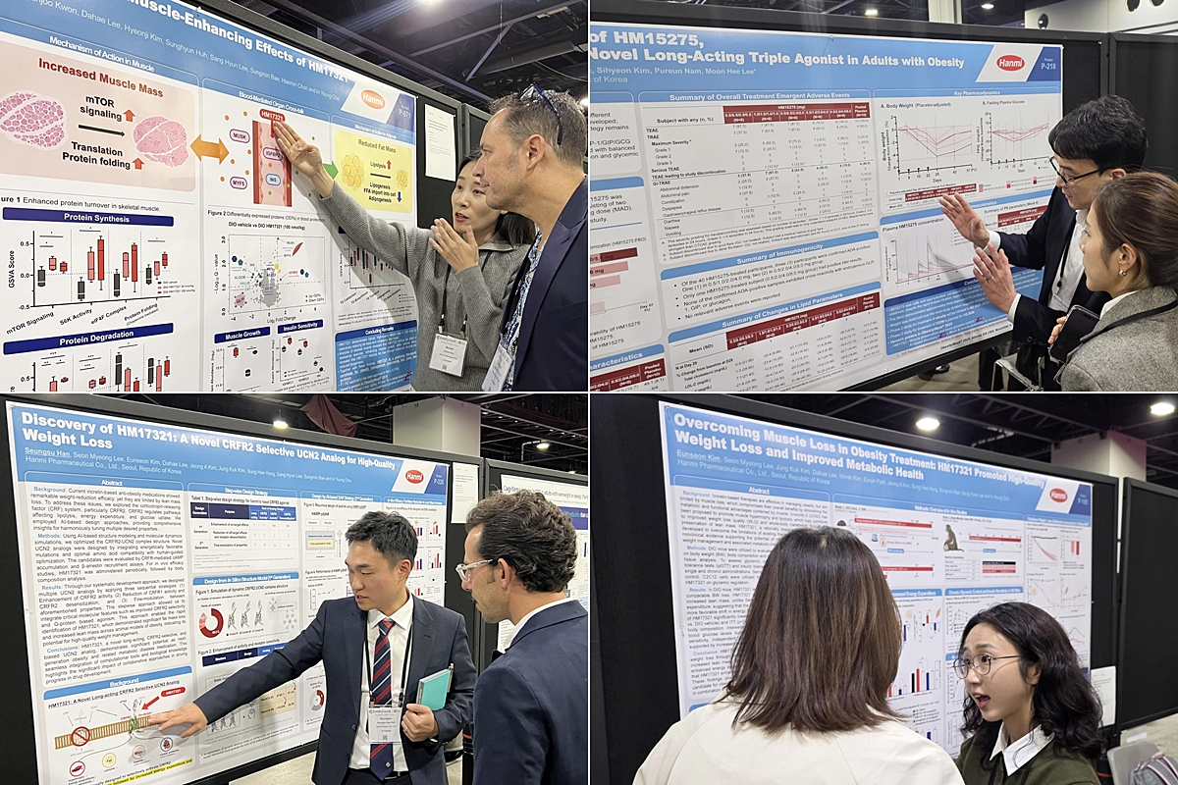
Researchers from Hanmi’s R&D and Clinical Teams explain study findings on HM17321 and HM15275 to attendees at ObesityWeek 2025
(November 10, 2025) Hanmi Pharmaceutical presented new research at ObesityWeek 2025 for its next-generation obesity drug candidates designed to achieve both weight reduction and muscle growth. With presentations for the second consecutive year at the largest pharmaceutical market in the world, Hanmi further strengthened recognition of its differentiated innovation capabilities and reinforced its position in the global obesity R&D landscape.

Hanmi announced that it presented four research studies on HM17321, a long-acting, CRFR2-selective UCN2 analog, and HM15275, a long-acting GLP-1/GIP/GCG triple agonist, during the conference held from November 4 to 7 in Atlanta. The company is advancing HM17321 and HM15275 toward First-in-Class and Best-in-Class therapeutic profiles, respectively, based on multi-pathway mechanisms and precision drug design strategies intended to address unmet needs in obesity treatment.

HM17321 has been engineered to promote muscle hypertrophy while selectively reducing fat mass, enabling high-quality weight reduction. The candidate was discovered using Hanmi’s proprietary AI-driven Research Platform, HARP. In diet-induced obese animal models, HM17321 activated the mTOR pathway in skeletal muscle, supporting muscle growth, while simultaneously inducing lipolysis and suppressing lipogenesis in adipose tissue. These effects were accompanied by improvements in insulin resistance and metabolic parameters.

In comparative studies with semaglutide, HM17321 demonstrated distinct differentiation, including greater fat mass reduction, increased lean mass, and higher energy expenditure. Chronic dosing of HM17321 also resulted in superior glycemic control in intraperitoneal glucose tolerance and insulin tolerance tests, and improved overall muscle functionality, including exercise efficiency and glucose utilization.

These findings highlight HM17321’s potential to support sustainable and metabolically favorable weight management, and clearly distinguish it from conventional approaches that focus solely on weight reduction or muscle preservation. HM17321 received FDA clearance for Phase 1 clinical evaluation earlier this month.

HM15275 is designed based on Hanmi’s extensive incretin research expertise, optimizing the balance of GLP-1, GIP, and glucagon receptor activation to support clinically meaningful weight reduction alongside broader metabolic improvements. At ObesityWeek 2025, Hanmi presented additional analyses from the Phase 1 clinical trial confirming favorable safety and tolerability, pharmacokinetic properties consistent with long-acting exposure, and supportive trends in weight and glycemic control. HM15275 has received FDA clearance for Phase 2 development, and the Phase 2 clinical trial is currently underway.

In-Young Choi, Head of Hanmi’s R&D Center, said, “This year’s presentations at ADA, EASD, and ObesityWeek demonstrate the scientific progress of HM17321 and HM15275, reflecting our long-standing commitment to advancing innovation in incretin and metabolic disease research. Hanmi will continue developing global first- and best-in-class obesity therapies that support healthy, sustainable, and high-quality weight loss for patients worldwide.”

According to GlobalData patent analytics (2021–2023), Hanmi ranks first globally in patent filings related to GLP-1 and metabolic obesity drug development technologies.

■ Contact info:
Hanmi Pharmaceutical (www.hanmipharm.com)
innovation@hanmi.co.kr, +82-02-410-0467

