Hanmi Showcases Innovative Pharmaceutical Technologies at CPHI Worldwide 2025
Operates an Independent Booth at the Exhibition in Frankfurt (Oct 28–30) to Expand Global Partnerships
Featuring Blockbuster Products Including Rosuzet and Amosartan, R&D Excellence, and the Hanmi Bioplant
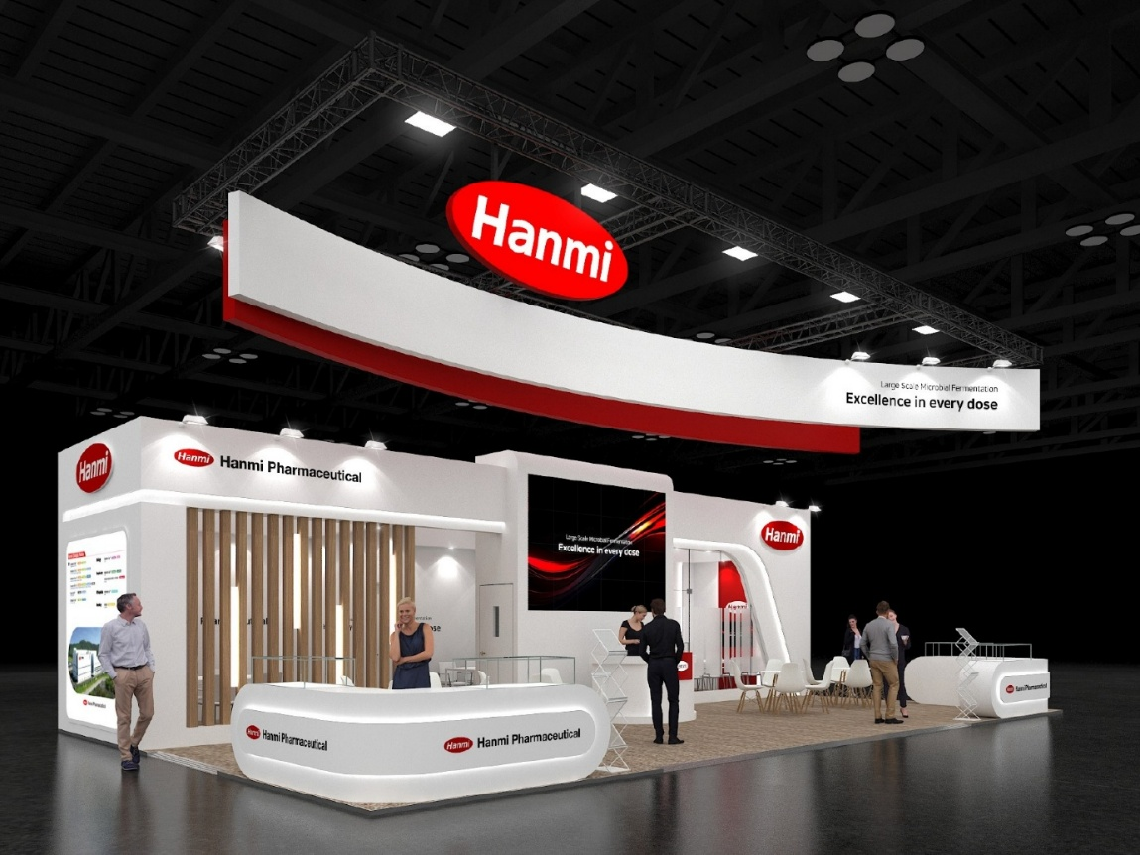
Hanmi Pharmaceutical’s independent booth at CPHI Worldwide 2025, held from October 28 to 30 in Frankfurt, Germany.
(October 28, 2025) Hanmi Pharmaceutical announced its participation in CPHI Worldwide 2025, the world’s largest pharmaceutical exhibition taking place from October 28 to 30 in Frankfurt, Germany.

At the event, Hanmi is showcasing its proprietary blockbuster combination therapies such as Rosuzet, Amosartan, and Gugutams at an independent booth, highlighting the company’s strong formulation and manufacturing capabilities. Hanmi will also introduce its innovative R&D pipelines and advanced CDMO services to further expand global partnerships.

CPHI Worldwide is the world’s largest pharmaceutical exhibition, held annually across major European cities. This year’s event features over 2,400 participating companies from 166 countries, with over 62,000 industry professionals expected to attend.

Hanmi will showcase over 30 novel drug candidates currently in development across key therapeutic areas including obesity and metabolic diseases, oncology, and rare diseases, while seeking collaboration opportunities with leading global pharmaceutical companies.

Hanmi is also promoting Rolontis, a long-acting G-CSF biologic developed using its proprietary LAPSCOVERY™ technology. Rolontis is Korea’s 33rd new drug and the first biologic oncology therapy developed by a Korean company to receive U.S. FDA approval. Since its U.S. launch in 2022 (under the brand name Rolvedon), Rolontis has achieved cumulative sales exceeding KRW 200 billion (approximately USD 150 million), driven by its proven efficacy and safety.

The success of Rolontis underscores the advanced manufacturing capabilities of Hanmi Bioplant, Hanmi’s world-class biopharmaceutical production site, which supplies the active drug substance for the U.S. market. The facility complies with the latest cGMP standards certified by both the U.S. FDA and Korea’s MFDS.

Unlike most domestic CDMO facilities that rely on mammalian cell culture systems, Hanmi Bioplant is equipped for microbial-based biomanufacturing, enabling faster and more cost-efficient large-scale production. The facility also features advanced fermentation and purification systems with bioreactors of up to 25,000 liters, along with specialized personnel and systems supporting full end-to-end services—from cell line development and process optimization to clinical/commercial production, quality testing, and regulatory documentation.

A Hanmi spokesperson said, “Through proprietary innovation and locally tailored strategies, Hanmi is accelerating its global expansion in the healthcare market. We will continue to strengthen our global presence by promoting the CDMO capabilities of our world-class Hanmi Bioplant, which fully meets global manufacturing standards.”

■ Contact info:
Hanmi Pharmaceutical (www.hanmipharm.com)
innovation@hanmi.co.kr, +82-02-410-0467

