Beyond Pouch Packaging: Hanmi Pharmaceutical Introduces a New Automated Vial Dispensing Solution in Canada and the United States

Hanmi Pharmaceutical Global Business Headquarters Accelerates Expansion into Canadian and US Markets, Strengthening Collaboration with Distribution Partner McKesson
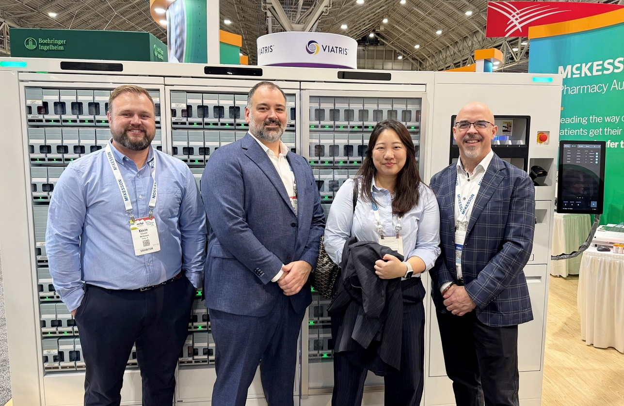
Introducing ‘Countmate’: A Customized Solution for Canadian and American Pharmacists Seeking Advanced Vial Preparation Technology
Hanmi Pharmaceutical and McKesson Automation representatives pose for a commemorative photo at the ASHP 2024 exhibition in New Orleans, USA. Pictured from left: McK Kevin Cloutier (Vice President of Sales & Business Development, McKesson Pharmacy Automation, USA), Yves Blanchette (Vice President of Technology Solutions, McKesson Canada), Hanmi Pharmaceutical Overseas Sales Team Leader Lee Ji-hyun, and McK Steve Dennison (Vice President and General Manager, McKesson Canada Automation).

Hanmi Pharmaceutical's Global Business Headquarters Overseas Sales Team is making significant strides in penetrating the Canadian and US markets with innovative products developed by its affiliate, JVM Co., Ltd. (054950.KQ)

Hanmi Pharmaceutical (KOSPI: 128940, CEO: Jae-Hyun Park) announced on February 14 that it recently unveiled Countmate, a fully automated vial dispensing machine tailored to the unique preferences of the Canada and US market. Unlike Korea, where medications are commonly dispensed in pouch form, the pharmaceutical industry in Canada and US predominantly relies on the vial method, which involves packaging drugs in plastic bottles. With the launch of Countmate, Hanmi aims to strengthen its presence in the region and drive significant growth in its global sales.

Countmate streamlines the entire dispensing process—from drug counting and dispensing to labeling, image verification, and final vial discharge—within a fully automated system. Hanmi Pharmaceutical highlighted that this launch marks a significant expansion of JVM’s product lineup, which had previously been centered on pouch-type dispensing equipment. "By adding vial dispensing capabilities with Countmate, we anticipate substantial growth in our global sales, particularly in Canada and US" the company stated.

To ensure a successful market entry, Hanmi Pharmaceutical worked closely with McKesson Automation (McK), the Canada and US distributor for JVM and a key partner in the region. Countmate was officially introduced to the public at the ASHP (American Society of Health-System Pharmacists) Midyear 2024 Conference, held in New Orleans, USA, from December 9 to 12 last year.

The ASHP Midyear Conference is the largest gathering of pharmacy professionals in the United States, hosting an annual event where industry experts convene to discuss key topics such as medication management, regulatory compliance, and pharmacy optimization.
Countmate is designed with cutting-edge technology to revolutionize pharmacy operations. It integrates multiple front-mounted canisters for automatic drug counting, an orthogonal robot for precise vial labeling, and seamless image verification before discharge.

Configurable with 84 or 168 canisters based on pharmacy size and needs, the system can process up to 160 prescriptions per hour, ensuring high efficiency for busy operations.

The machine also enhances quality control with built-in cameras that capture top and side images of each vial, ensuring thorough verification. Additional features that support operational efficiency include: automatic vial sorting and supply, automated label attachment, patient-specific vial discharge sorting, and one sided operation design to maximize the pharmacy space efficiency with low-noise operation.

Beyond its technical sophistication, Countmate prioritizes safety and user convenience. Key benefits include: Safety sensors to prevent accidents by detecting human presence during operation, hygienic preparation processes for contamination-free vial handling, and a compact, space-efficient design adaptable to various pharmacy layouts for seamless installation and operation.

Hanmi anticipates that Countmate's advanced functionality and competitive pricing will make it an attractive option for pharmacies introducing automated equipment for the first time.

The development of Countmate was achieved through close collaboration between Hanmi and JVM, with a focus on optimizing its design by analyzing and adapting to the unique pharmaceutical formulation patterns of the Canadian and the US markets. Furthermore, Hanmi continues to maintain a strong partnership with McKesson to ensure the product's successful launch and sustained growth in the region.

A representative of Hanmi Pharmaceutical's Global Business Division stated that Countmate embodies innovative technology designed to meet the unique needs of the Canadian and the US market. He credited the product's success to the synergy between Hanmi and JVM's technological expertise and McKesson's deep market knowledge and extensive network.
Hanmi Pharmaceutical CEO Park Jae-hyun remarked, "Moving forward, Hanmi will actively pursue business opportunities that create synergy across the entire group. We are committed to expanding our global footprint and will make every effort to further increase the overseas share of our total sales."

<The End>
■ Contact info:
〮Official Websites: www.hanmipharm.com
innovation@hanmi.co.kr, +08-2-410-0467

