Hanmi Pharmaceutical's New SBS Drug Secures INN Listing as 'Sonefpeglutide'
WHO Officially Registers Sonefpeglutide as an INN, Signifying 'Lapscovery-Applied, Sustained-Release GLP-2 Analog'
World’s First Once-Monthly Dosage Form: Global Phase 2 Clinical Trials Advancing Smoothly
Phase 1 Pharmacokinetic Data on Sonefpeglutide Presented at ESPEN, Showcasing Its Innovative Potential
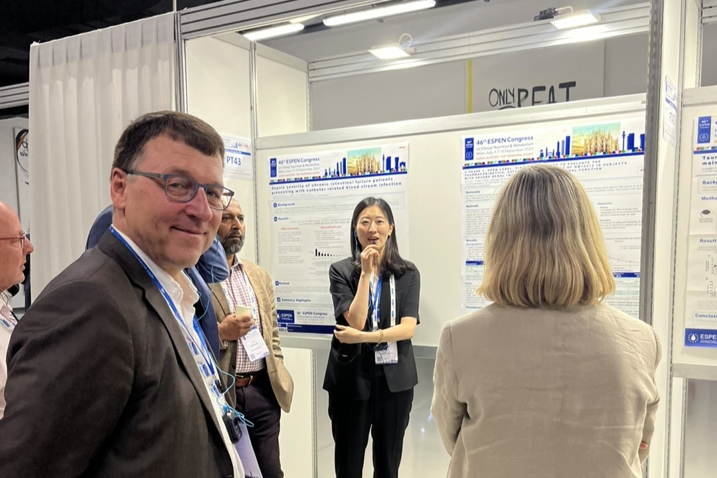
At the European Society of Clinical Nutrition and Metabolism (ESPEN) conference in Milan, Italy, this September, Moon Hee Lee, Head of General Medicine Clinical Team at Hanmi Pharmaceutical, presented Phase 1 pharmacokinetic data on sonefpeglutide, an investigational therapy for short bowel syndrome.
The World Health Organization (WHO) has officially designated the international nonproprietary name (INN) for the groundbreaking drug for short bowel syndrome (SBS) of Hanmi Pharmaceutical as ‘sonefpeglutide’. This new treatment, a LAPS GLP-2 analog (HM15912), represents the world's first once-monthly dosage form for the SBS.

The name 'sonefpeglutide' combines 'ef-' (signifying Hanmi’s proprietary Lapscovery platform that enhances the efficacy of biologics) with '-glutide' (indicating a glucagon-like peptide analogue), highlighting its role as a long-acting GLP-2 analog developed with advanced technology. Henceforth, products containing these components should label the inclusion as 'sonefpeglutide.'

SBS, a rare condition characterized by the loss of more than 60% of the small intestine due to congenital or acquired causes, leads to malabsorption and malnutrition, affecting approximately 24.5 out of every 100,000 newborns globally. The condition significantly impacts patients' survival and growth and also affects adults, often resulting from surgeries related to inflammatory bowel disease, intestinal volvulus, trauma, or tumors.

Hanmi is developing sonefpeglutide as the world’s first once-monthly dosage form for treating SBS, currently in phase 2 global clinical trials. Upon commercialization, this innovative drug is expected to significantly alleviate patient’s suffering by sustained therapeutic effect, improved safety, and enhanced convenience of administration.

In September, Hanmi presented promising phase 1 trial results at the European Society of Clinical Nutrition and Metabolism (ESPEN) in Milan, Italy, demonstrating its potential as a next-generation long-acting rare disease treatment.

The trial compared pharmacokinetic characteristics between subjects with severe renal impairment and those with normal renal function. In both groups, sonefpeglutide was well tolerated and safe. Additionally, the pharmacokinetic profiles were similar.

These results suggest that dose adjustment of sonefpeglutide is not necessary even in patients with short bowel syndrome-associated intestinal failure (SBS-IF) accompanied by renal dysfunction. Based on these findings, Hanmi is exploring the innovative potential of sonefpeglutide as a new treatment option for SBS by relaxing the estimated glomerular filtration rate (eGFR) limit on the currently ongoing Phase 2 clinical trial.

Moon Hee Lee, Head of General Medicine Clinical Team at Hanmi Pharmaceutical, highlighted the significance of this development, noting, “The currently approved treatment for SBS (teduglutide) requires daily subcutaneous injections and is prohibitively expensive, especially in Korea where it is not covered by insurance." She added, "We will do our utmost in clinical development, collaborating with international experts, to ensure that sonefpeglutide will be able to approved as a new treatment that significantly improves the quality of life for patients suffering from rare diseases.”

To this day, sonefpeglutide has garnered significant regulatory recognition. It was designated an orphan drug by the US FDA, European Medicines Agency (EMA), and Korea's Ministry of Food and Drug Safety in 2019. Additionally, it achieved pediatric orphan drug designation (RPD) from the FDA in 2020 and was granted fast-track status in 2021.

<The End>
■ Contact info:
〮Official Websites: www.hanmipharm.com
innovation@hanmi.co.kr, +08-2-410-0467

