Hanmi Pharmaceutical's Groundbreaking Drug for Congenital Hyperinsulinism, 'Efpegerglucagon' Advances in Global Phase 2 Clinical Trial <World’s first once-weekly treatment for congenital hyperinsulinism under development>

Hanmi unveiled phase 2 interim results at the European Society for Paediatric Endocrinology (ESPE)
Excellent safety, tolerability, and efficacy, raising expectations for commercialization
Ongoing support for the patients association since 2020 demonstrates Hanmi's commitment to patient care

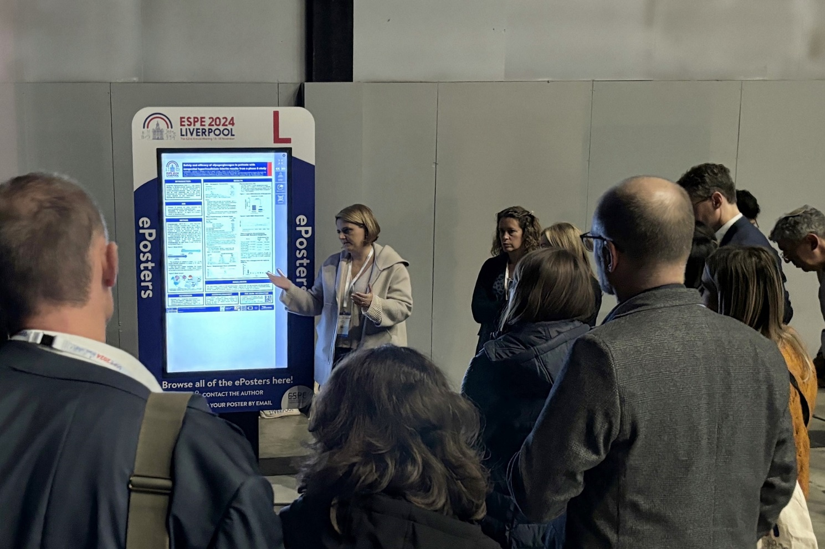
Dr. Antonia Dastamani from Great Ormond Street Hospital (GOSH) presented the interim results of the Phase 2 trial for Efpegerglucagon at the European Society for Paediatric Endocrinology in Liverpool, UK, on November 18

Hanmi announced promising results from the Phase 2 clinical trials of efpegerglucagon (HM15136), a groundbreaking drug under development as the world’s first once-weekly treatment for congenital hyperinsulinism (CHI). The results, presented at the European Society for Paediatric Endocrinology (ESPE) in Liverpool, UK, highlighted the drug's potential to improve the quality of life for patients with this rare and challenging disease.

On November 9, Hanmi announced its participation in the European Society for Paediatric Endocrinology (ESPE) conference, held in Liverpool, United Kingdom, from November 16 to 18. During the event, the company presented research findings and interim analysis results from Phase 2 clinical trial of efpegerglucagon, a groundbreaking treatment under development for congenital hyperinsulinism. The data were shared through a poster presentation and an e-poster oral presentation.

Congenital hyperinsulinism is a rare condition characterized by excessive insulin secretion, leading to recurrent severe hypoglycemia. The condition affects approximately 1 in 25,000 to 50,000 individuals, with around 300 new cases diagnosed annually in the US and Europe. Existing treatment options are limited (1 existing), with frequent side effects (hypertrichosis, fluid retention, heart failure, etc.) and efficacy restricted to certain genotypes. Therefore, in many cases, patients are forced to rely on off-label medications or undergo pancreatectomy, a procedure that can result in long-term complications.

Hanmi’s efpegerglucagon aims to address these challenges by offering a once-weekly treatment option. The phase 2 clinical trial, designed to evaluate the safety, tolerability, pharmacokinetics, and efficacy of the drug, involves a dose-escalation and proof-of-concept approach.

During the ESPE conference, Hanmi disclosed interim analysis results based on data from the first six subjects in Cohort 1, each treated for eight weeks. The findings demonstrated excellent safety and tolerability. No significant changes were observed in vital signs, physical examinations, safety laboratory tests, or electrocardiograms.
Furthermore, no adverse events leading to discontinuation of study treatment or adverse events of special interest were reported.

Importantly, efpegerglucagon significantly reduced the frequency and duration of hypoglycemia (blood glucose 70 mg/dL) and severe hypoglycemia (blood glucose lower than 54 mg/dL). Pharmacokinetic analysis revealed an average half-life of 146 hours at Week 8, supporting its suitability for once-weekly dosing. These results suggest that efpegerglucagon has the potential to greatly alleviate the burden of CHI treatment, offering sustained therapeutic benefits and a more manageable administration schedule.

Dr. Antonia Dastamani, a researcher at Great Ormond Street Hospital (GOSH) in the UK, who presented the interim results at ESPE, remarked on the promising nature of the findings. “The safety and efficacy profile of efpegerglucagon observed so far is very promising. Based on the experiences of the clinical trial participants, we are optimistic about its potential to significantly improve patients' quality of life,” she said.
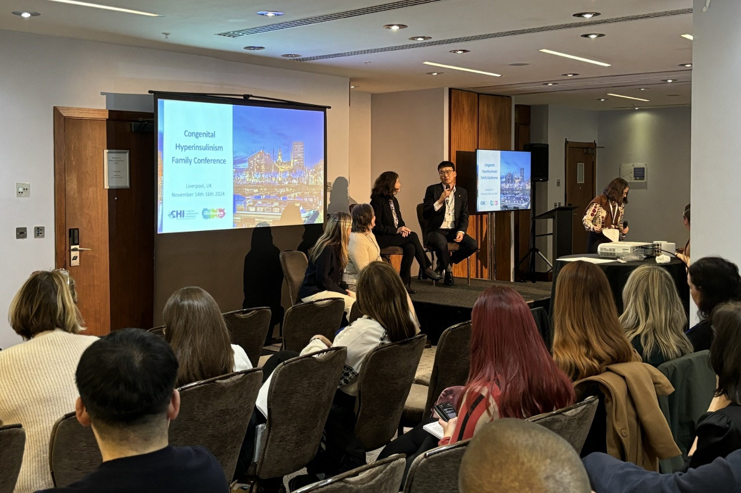
At the CHI symposium in Liverpool, UK, on November 15, JaeDuk Choi, GM Clinical Team Leader at Hanmi Pharmaceutical, discussed the potential and innovative features of efpegerglucagon (HM15136).

In addition to presenting clinical trial data, Hanmi participated in a symposium hosted by Congenital Hyperinsulinism International in Liverpool, United Kingdom from November 14 to 16. The organization engaged with patients and their families, demonstrating its commitment to addressing the challenges faced by the CHI community.

Congenital Hyperinsulinism International, a non-profit organization founded in 2005, hosts annual family meetings to connect families with medical experts, including doctors, researchers, and professionals from the pharmaceutical industry. These gatherings aim to share the latest advancements in treatments and clinical updates and foster a supportive network.

Congenital hyperinsulinism, primarily caused by genetic abnormalities, manifests shortly after birth and leads to recurrent severe hypoglycemia. Without proper treatment, it can result in brain damage, significantly impacting both the patients and their families.

Hanmi has supported the Congenital Hyperinsulinism International since 2020, providing hope and encouragement to those affected by this rare condition.

Moon Hee Lee, Head of Hanmi’s GM Clinical Team, emphasized the company’s mission-driven approach. “Developing treatments for rare diseases is a mission we embrace fully, considering the profound pain experienced by patients and their families. We remain committed to commercializing a congenital hyperinsulinism treatment that establishes a new paradigm in patient care,” she stated.

<The End>
■ Contact info:
〮Official Websites: www.hanmipharm.com
innovation@hanmi.co.kr, +08-2-410-0467

