'Efocipegtrutide' by Hanmi Pharmaceutical Shows Promising Efficacy in Liver Fibrosis Improvement

Hanmi Presents Non-Clinical Study Results at the American Association for the Study of Liver Diseases
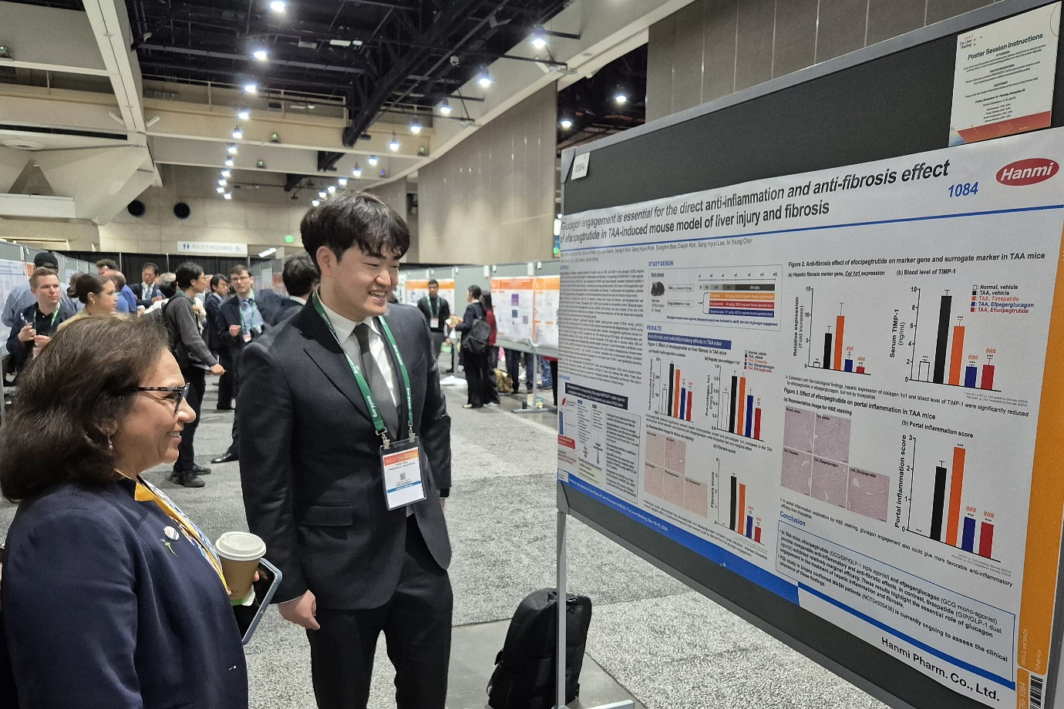
Direct Effect Confirmed on Improving Liver Fibrosis, a Key Indicator in MASH Treatment
IDMC Endorses Continued Development; Global Phase 2b Clinical Trials Progressing Smoothly
Researcher Yohan Kim (right) from Hanmi Pharm R&D Center explaining research findings on efocipegtrutide to Dr. Manal F. Abdelmalek, a leading global authority in MASH research, at the AASLD conference in San Diego on November 15 (PST).
At the American Association for the Study of Liver Diseases (AASLD) International Conference held in San Diego from November 15–19 (PST), Hanmi Pharmaceutical unveiled groundbreaking non-clinical findings for its novel MASH (Metabolic dysfunction-associated steatohepatitis) drug, efocipegtrutide (^{LAPS} Triple Agonist). The study highlights efocipegtrutide’s unique ability to directly improve liver fibrosis—a critical indicator for effective MASH treatment—through glucagon activation.

Efocipegtrutide is a novel triple-action biopharmaceutical designed to simultaneously activate glucagon, which boosts energy metabolism; glucagon-like peptide-1 (GLP-1), for insulin secretion and appetite suppression; and gastric inhibitory peptide (GIP) receptors, to support insulin secretion and exert anti-inflammatory effects. This triple-action mechanism positions efocipegtrutide as a differentiatedherapeutic candidate by addressing the core symptoms of MASH, including fatty liver, inflammation, and fibrosis.

Non-clinical studies compared efocipegtrutide with other investigational drugs, such as semaglutide and tirzepatide, using animal models of liver inflammation and fibrosis. Repeated administration of efocipegtrutide resulted in consistent improvement of liver tissue inflammation and fibrosis. However, other investigational drugs had minimal effect, demonstrating the unique efficacy of efocipegtrutide through glucagon engagement - a mechanism not present in semaglutide and tirzepatide.

Despite numerous candidates in clinical development, no current therapy has shown a significant impact on liver fibrosis improvement. Distinctive non-clinical results of efocipegtrutide suggest its potential to become a breakthrough treatment for MASH, addressing a substantial unmet medical need.

Hanmi Pharmaceutical is conducting global Phase 2b clinical trials across the United States and Korea to evaluate efficacy, safety, and tolerability of efocipegtrutide in biopsy-confirmed MASH patients with liver fibrosis. The Independent Data Monitoring Committee (IDMC) has recommended continuing the trials without modifications across all dose groups.

Efocipegtrutide has received Fast Track designation from the U.S. FDA for MASH treatment. Additionally, it has been granted orphan drug status by both the FDA and EMA for various fibrotic diseases of high unmet medical needs such as idiopathic pulmonary fibrosis (IPF), primary biliary cholangitis (PBC), and primary sclerosing cholangitis (PSC).

Dr. In Young Choi, Head of Hanmi R&D Center, commented: "With our extensive expertise in metabolic disease research, we are committed to advancing innovative solutions for MASH treatment. As the global MASH market is projected to grow to around $20.6 billion (30 trillion in KRW), efocipegtrutide is poised to redefine treatment paradigms and improve patient outcomes."

<The End>
■ Contact info:
〮Official Websites: www.hanmipharm.com
innovation@hanmi.co.kr, +08-2-410-0467

