**Recent Data for Hanmi’s 'Novel Long-Acting GLP-1/GIP/GCG Triple Agonist' Support Potential for ‘Best-In-Class’ Weight Loss Effect in Treating Obesity**

* **Hanmi Pharm. Co., Ltd., presented four non-clinical research results for the first time at American Diabetes Association 84th Scientific Session, held from June 21 to 24**
* 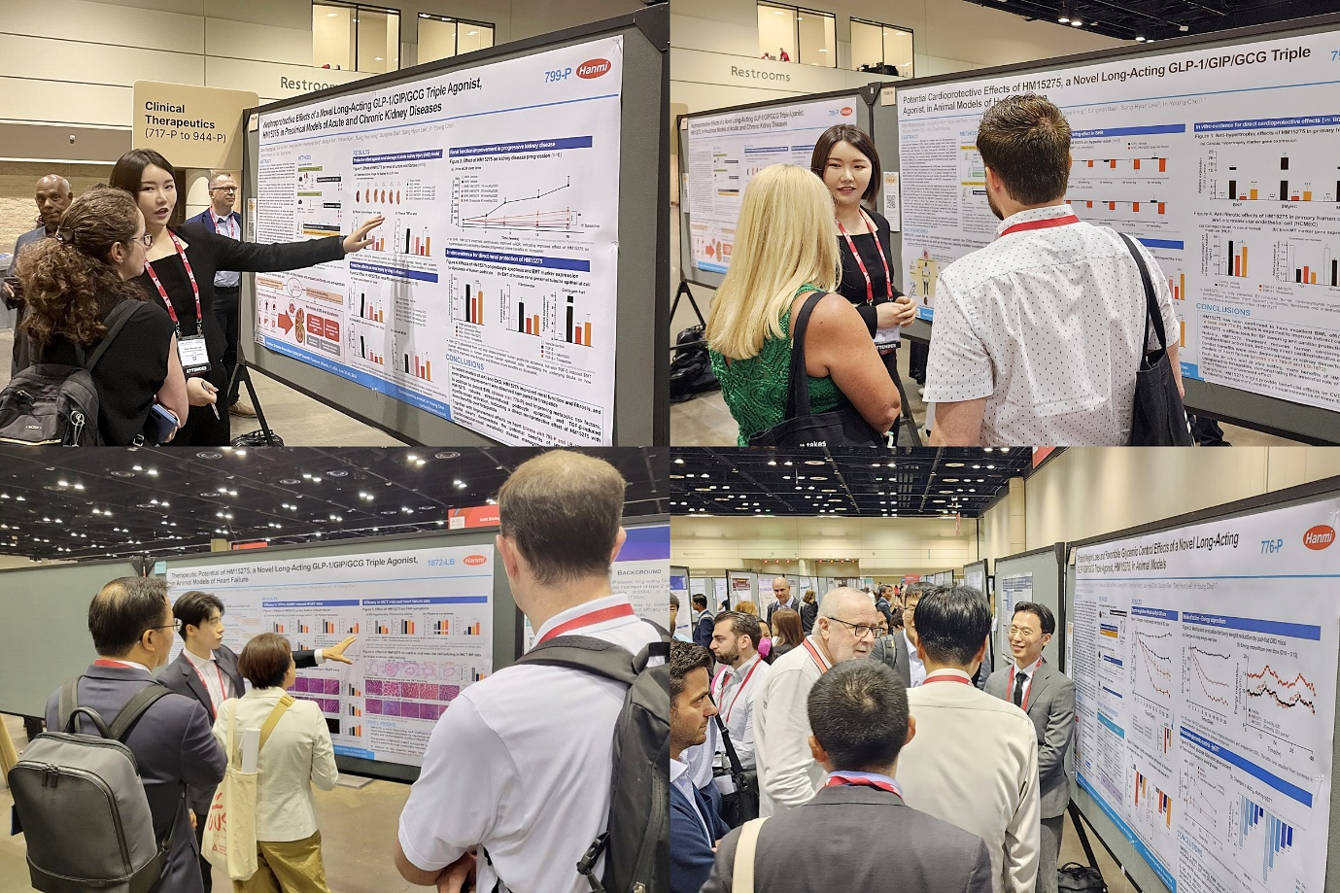**HM15275 also demonstrated cardio-renal protection against various *in vivo* models, confirming its potential to treat cardiac hypertrophy, heart failure, and kidney disease**

**Researchers at Hanmi R&D Center explained the main research details of HM15275, a next-generation triple agonist treatment for obesity, at the American Diabetes Association.**

Key non-clinical highlights of Hanmi Pharmaceutical's novel long-acting triple agonist (LA-GLP/GIP/GCG, code name: HM15275) for obesity treatment, which is expected to reduce weight by more than 25% while minimizing lean mass loss, were presented at a world-renowned diabetes society conference. The drug candidate received significant attention upon its announcement.

On June 25, Hanmi announced its participation in the 'American Diabetes Association (ADA 2024)' held in Orlando, USA, from June 21 to 24. At ADA 2024, the company presented four non-clinical study results as a poster, suggesting HM15275’s ‘best-in-class’ potential for weight loss and its differentiated benefits on cardiovascular renal and metabolic (CVRM) disorders.

By utilizing Hanmi’s expertise on incretin science, HM15275 was rationally designed to have optimized triple agonistic activity balance between the glucagon-like peptide-1 (GLP-1), gastric inhibitory peptide (GIP), and glucagon (GCG) for efficient management of both obesity and CVRM.

Current GLP-1-based drugs such as semaglutide and tirzepatide, have shown a weight loss effect of approximately 15-20% in obesity treatment clinical trials. However, there remains an unmet medical need, as they do not achieve weight loss comparable to bariatric surgery (≥25%).

The company's nonclinical research demonstrated the superior weight loss effect of HM15275 in obese animal models compared to existing treatments. This was achieved through a mechanism of action involving simultaneous regulation of satiety and energy metabolism due to the optimized triple pharmacological action of HM15275.

Furthermore, the company highlighted HM15275's potential for indication expansion. Incretin-based drugs are expanding beyond diabetes and obesity treatment to other therapeutic areas, particularly in improving cardiovascular and kidney diseases. According to related investigation in human-relevant animal disease models, HM15275 showed promise for cardioprotective effects superior to existing treatments for cardiac hypertrophy, cardiac fibrosis, and heart failure. Consistently, HM15275 also showed improvement effect on kidney function and fibrosis. Subsequent mechanism studies revealed that HM15275 could confer direct tissue protection effect in addition to the indirect effects from efficient weight loss and glycemic control.

The U.S. Food and Drug Administration cleared an application for an investigational new drug (IND) of HM15275 for the treatment of obesity in May, and Hanmi initiated a Phase 1 clinical study by enrolling patients and completing the first subject first dose in mid-June.

Dr. In Young Choi, Head of Hanmi R&D Center, said, “The presentation at ADA 2024 marked a significant milestone for Hanmi as it unveiled data on its 'next-generation obesity drug' for the first time at an international conference, solidifying the company's leading position in the field of obesity and metabolic disease treatment." He added, "Following our incretin based pipelines, efpeglenatide and HM15275, we also plan to disclose a new obesity treatment pipeline with a non-incretin mechanism of action during the fourth quarter of this year."

**<The End>**

■ Contact info:

〮Official Websites: [www.hanmipharm.com](http://www.hanmipharm.com)

[innovation@hanmi.co.kr](mailto:innovation@hanmi.co.kr), +08-2-410-0467